Unit-3

Single Phase Voltage Transformer

3.1 Introduction
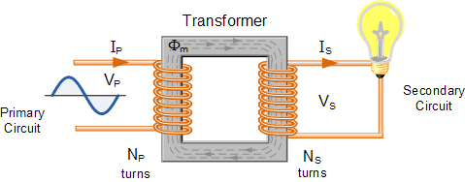
In other words, for a transformer there is no direct electrical connection between the two coil windings, thereby giving it the name also of an Isolation Transformer. Generally, the primary winding of a transformer is connected to the input voltage supply and converts or transforms the electrical power into a magnetic field. While the job of the secondary winding is to convert this alternating magnetic field into electrical power producing the required output voltage as shown.

3.2 Transformer Construction (single-phase)
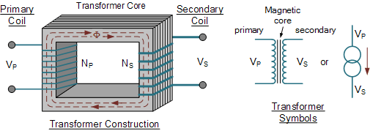
- Where:
- V_{P} - is the Primary Voltage
- V_{S} - is the Secondary Voltage
- N_{P} - is the Number of Primary Windings
- N_{S} - is the Number of Secondary Windings
- Φ (phi) - is the Flux Linkage
Notice that the two coil windings are not electrically connected but are only linked magnetically. A single-phase transformer can operate to either increase or decrease the voltage applied to the primary winding. When a transformer is used to “increase” the voltage on its secondary winding with respect to the primary, it is called a Step-up transformer. When it is used to “decrease” the voltage on the secondary winding with respect to the primary it is called a Step-down transformer.
However, a third condition exists in which a transformer produces the same voltage on its secondary as is applied to its primary winding. In other words, its output is identical with respect to voltage, current and power transferred. This type of transformer is called an “Impedance Transformer” and is mainly used for impedance matching or the isolation of adjoining electrical circuits.
The difference in voltage between the primary and the secondary windings is achieved by changing the number of coil turns in the primary winding ( N_{P} ) compared to the number of coil turns on the secondary winding ( N_{S} ).
As the transformer is basically a linear device, a ratio now exists between the number of turns of the primary coil divided by the number of turns of the secondary coil. This ratio, called the ratio of transformation, more commonly known as a transformers “turns ratio”, ( TR ). This turns ratio value dictates the operation of the transformer and the corresponding voltage available on the secondary winding.
It is necessary to know the ratio of the number of turns of wire on the primary winding compared to the secondary winding. The turns ratio, which has no units, compares the two windings in order and is written with a colon, such as 3:1 (3-to-1). This means in this example, that if there are 3 volts on the primary winding there will be 1 volt on the secondary winding, 3 volts-to-1 volt. Then we can see that if the ratio between the number of turns changes the resulting voltages must also change by the same ratio, and this is true.
Transformers are all about “ratios”. The ratio of the primary to the secondary, the ratio of the input to the output, and the turns ratio of any given transformer will be the same as its voltage ratio. In other words for a transformer: “turns ratio = voltage ratio”. The actual number of turns of wire on any winding is generally not important, just the turns ratio and this relationship is given as:

A Transformers Turns Ratio
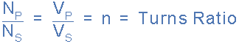

3.3 Working Principle
We have seen that the number of coil turns on the secondary winding compared to the primary winding, the turns ratio, affects the amount of voltage available from the secondary coil. But if the two windings are electrically isolated from each other, how is this secondary voltage produced?
We have said previously that a transformer basically consists of two coils wound around a common soft iron core. When an alternating voltage ( V_{P} ) is applied to the primary coil, current flows through the coil which in turn sets up a magnetic field around itself, called mutual inductance, by this current flow according to Faraday’s Law of electromagnetic induction. The strength of the magnetic field builds up as the current flow rises from zero to its maximum value which is given as dΦ/dt.
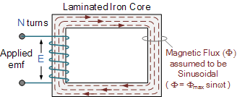
As the magnetic lines of force setup by this electromagnet expand outward from the coil the soft iron core forms a path for and concentrates the magnetic flux. This magnetic flux links the turns of both windings as it increases and decreases in opposite directions under the influence of the AC supply.
However, the strength of the magnetic field induced into the soft iron core depends upon the amount of current and the number of turns in the winding. When current is reduced, the magnetic field strength reduces.
When the magnetic lines of flux flow around the core, they pass through the turns of the secondary winding, causing a voltage to be induced into the secondary coil. The amount of voltage induced will be determined by: N*dΦ/dt (Faraday’s Law), where N is the number of coil turns. Also this induced voltage has the same frequency as the primary winding voltage.
Then we can see that the same voltage is induced in each coil turn of both windings because the same magnetic flux links the turns of both the windings together. As a result, the total induced voltage in each winding is directly proportional to the number of turns in that winding. However, the peak amplitude of the output voltage available on the secondary winding will be reduced if the magnetic losses of the core are high.
If we want the primary coil to produce a stronger magnetic field to overcome the cores magnetic losses, we can either send a larger current through the coil, or keep the same current flowing, and instead increase the number of coil turns ( N_{P} ) of the winding. The product of amperes times turns is called the “ampere-turns”, which determines the magnetising force of the coil.
So assuming we have a transformer with a single turn in the primary, and only one turn in the secondary. If one volt is applied to the one turn of the primary coil, assuming no losses, enough current must flow and enough magnetic flux generated to induce one volt in the single turn of the secondary. That is, each winding supports the same number of volts per turn

Transformer Construction of the Core
Generally, the name associated with the construction of a transformer is dependant upon how the primary and secondary windings are wound around the central laminated steel core. The two most common and basic designs of transformer construction are the Closed-core Transformer and the Shell-core Transformer.
In the “closed-core” type (core form) transformer, the primary and secondary windings are wound outside and surround the core ring. In the “shell type” (shell form) transformer, the primary and secondary windings pass inside the steel magnetic circuit (core) which forms a shell around the windings as shown below.
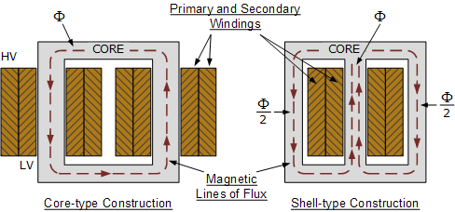
In the core type transformer construction, one half of each winding is wrapped around each leg (or limb) of the transformers magnetic circuit as shown above.
The coils are not arranged with the primary winding on one leg and the secondary on the other but instead half of the primary winding and half of the secondary winding are placed one over the other concentrically on each leg in order to increase magnetic coupling allowing practically all of the magnetic lines of force go through both the primary and secondary windings at the same time. However, with this type of transformer construction, a small percentage of the magnetic lines of force flow outside of the core, and this is called “leakage flux”.
Shell type transformer cores overcome this leakage flux as both the primary and secondary windings are wound on the same centre leg or limb which has twice the cross-sectional area of the two outer limbs. The advantage here is that the magnetic flux has two closed magnetic paths to flow around external to the coils on both left and right hand sides before returning back to the central coils.
This means that the magnetic flux circulating around the outer limbs of this type of transformer construction is equal to Φ/2. As the magnetic flux has a closed path around the coils, this has the advantage of decreasing core losses and increasing overall efficiency.
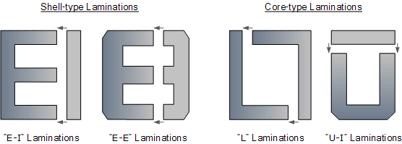

3.4 EMF Equation
As the magnetic flux varies sinusoidally, Φ = Φ_{max} sinωt, then the basic relationship between induced emf, ( E ) in a coil winding of N turns is given by:

emf = turns x rate of change
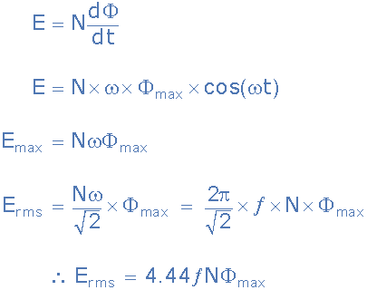
- Where:
- ƒ - is the flux frequency in Hertz, = ω/2π
- Ν - is the number of coil windings.
- Φ - is the amount of flux in webers
This is known as the Transformer EMF Equation. For the primary winding emf, N will be the number of primary turns, ( N_{P} ) and for the secondary winding emf, N will be the number of secondary turns, ( N_{S} ).
Also please note that as transformers require an alternating magnetic flux to operate correctly, transformers cannot therefore be used to transform or supply DC voltages or currents, since the magnetic field must be changing to induce a voltage in the secondary winding. In other words, transformers DO NOT operate on steady state DC voltages, only alternating or pulsating voltages.
If a transformers primary winding was connected to a DC supply, the inductive reactance of the winding would be zero as DC has no frequency, so the effective impedance of the winding will therefore be very low and equal only to the resistance of the copper used. Thus the winding will draw a very high current from the DC supply causing it to overheat and eventually burn out, because as we know I = V/R.

3.5 Transformer “No-load” Condition
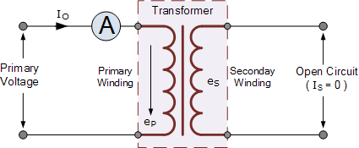

A transformer is said to be on “no-load” when its secondary side winding is open circuited, in other words, nothing is attached and the transformer loading is zero. When an AC sinusoidal supply is connected to the primary winding of a transformer, a small current, I_{OPEN} will flow through the primary coil winding due to the presence of the primary supply voltage.
With the secondary circuit open, nothing connected, a back EMF along with the primary winding resistance acts to limit the flow of this primary current. Obviously, this no-load primary current ( Io ) must be sufficient to maintain enough magnetic field to produce the required back emf. Consider the circuit below.

The ammeter above will indicate a small current flowing through the primary winding even though the secondary circuit is open circuited. This no-load primary current is made up of the following two components:
- An in-phase current, I_{E} which supplies the core losses (eddy current and hysteresis).
- A small current, I_{M} at 90º to the voltage which sets up the magnetic flux.
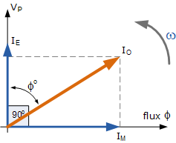
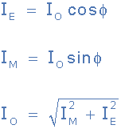
Note that this no-load primary current, Io is very small compared to the transformers normal full-load current. Also due to the iron losses present in the core as well as a small amount of copper losses in the primary winding, Io does not lag behind the supply voltage, Vp by exactly 90º, ( cosφ = 0 ), there will be some small phase angle difference.

3.6 Ampere turn balance

When the transformer is loaded, the current I₂ flows through the secondary winding. The magnetic and phase of I₂ is determined by the load. If load is inductive, I₂ lags V₂. If load is capacitive, I₂ leads V₂ while for resistive load, I₂ is in phase withV₂.
There exists a secondary m.m.f. N₂ I₂ due to which secondary current sets up its own flux Φ₂. This flux opposes the main flux Φ which is produced in the core due to magnetising component of no load current. Hence the m.m.f. is N₂ I₂ called demagnetising ampere-turns.
The flux Φ₂ momentarily reduces the main flux Φ, due to which the primary induced e.m.f. also E₁ reduces.

This additional current drawn by primary is due to the load hence called load component of primary current denoted as I₂'
This current I₂' is in antiphase with I₂. The current sets up its own flux Φ₂' which opposes the flux Φ₂ and helps the main fluxΦ. This flux Φ₂' neutralises the flux Φ₂ produced by I₂. The m.m.f. i.e. ampere turns N₂ I₂' balances the ampere turns N₂ I₂. Hence the net flux in the core is again maintained at constant level.
Key point : Thus for any load condition, no load to full load the flux in the core is practically constant.
The load component current I₂' always neutralises the changes in the loads. Hence the transformer is called constant flux machine.
As the ampere turns are balanced we can write,
N₂ I₂=N₂ I₂'
... I₂' =(N₂/N₁) = K I₂ ..................(1)
Thus when transformer is loaded, the primary current I₁ has two components :
1. The no load current I_{o} which lags V₁ by angle Φ_{o}. It has two components I_{m} and I_{c}.
2. The load component I₂' which in antiphase with I₂. And phase of I₂ is decided by the load.
Hence primary current I₁ is vector sum of I_{o} and I₂'.
... Ī₁ = Ī_{o} + Ī₂ ...............(2)
Assume inductive load, I₂ lags E₂ by Φ₂, the phasor diagram is shown in the Fig. 2(a).
Assume purely resistive load, I₂ in phase with E₂, the phasor diagram is shown in the Fig.2(b).
Assume capacitive load, I₂ leads E₂ by Φ₂, the phasor diagram is shown in the Fig. 2(c).
Note that I₂' is always in antiphase with I₂.
Actually the phase of I₂ is with respect to V₂ i.e. angle Φ₂ is angle between I₂ and V₂. For the ideal case, E₂ is assumed equal to V₂ neglecting various drops.
The current ratio can be verified from this discussion. As the no load current I_{o} is very small, neglecting I_{o} we can write,
I₁ ~ I₂'
Balancing the ampere turns,
N₁ I₁ = N₁ I₁ = N₂ I₂
... N₂ /N₁ = I₁ /I₂ = K
Under full load conditions when I_{o} is very small compared to full load currents, the ratio of primary and secondary current is constant.

3.7 Resistance and Leakage Reactance or Impedance of Transformer

Leakage Reactance of Transformer
All the flux in transformer will not be able to link with both the primary and secondary windings. A small portion of flux will link either winding but not both. This portion of flux is called leakage flux. Due to this leakage flux in transformer, there will be a self-reactance in the concerned winding. This self-reactance of transformer is alternatively known as leakage reactance of transformer. This self-reactance associated with resistance of transformer is impedance. Due to this impedance of transformer, there will be voltage drops in both primary and secondary transformer windings.

Resistance of Transformer
Generally, both primary and secondary windings of electrical power transformer are made of copper. Copper is a very good conductor of current but not a super conductor. Actually, super conductor and super conductivity both are conceptual, practically they are not available. So both windings will have some resistance. This internal resistance of both primary and secondary windings is collectively known as resistance of transformer.

Impedance of Transformer
As we said, both primary and secondary windings will have resistance and leakage reactance. These resistance and reactance will be in combination, is nothing but impedance of transformer. If R₁ and R₂ and X₁ and X₂ are primary and secondary resistance and leakage reactance of transformer respectively, then Z₁ and Z₂ impedance of primary and secondary windings are respectively,
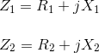
The Impedance of transformer plays a vital role during parallel operation of transformer.

Leakage Flux in Transformer
In ideal transformer, all the flux will link with both primary and secondary windings but in reality, it is impossible to link all the flux in transformer with both primary and secondary windings. Although maximum flux will link with both windings through the core of transformer but still there will be a small amount of flux which will link either winding but not both. This flux is called leakage flux which will pass through the winding insulation and transformer insulating oil instead of passing through core. Due to this leakage flux in transformer, both primary and secondary windings have leakage reactance. The reactance of transformer is nothing but leakage reactance of transformer. This phenomenon in transformer is known as Magnetic leakage.
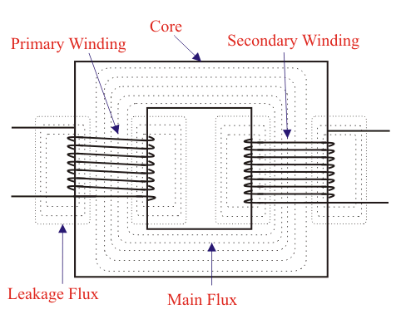
Voltage drops in the windings occur due to impedance of transformer. Impedance is combination of resistance and leakage reactance of transformer. If we apply voltage V₁across primary of transformer, there will be a component I₁X₁ to balance primary self induced emf due to primary leakage reactance. (Here, X₁ is primary leakage reactance). Now if we also consider voltage drop due to primary resistance of transformer, then voltage equation of a transformer can easily be written as,
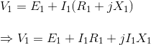
Similarly for secondary leakage reactance, the voltage equation of secondary side is,
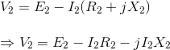
Here in the figure above, the primary and secondary windings are shown in separate limbs, and this arrangement could result in a large leakage flux in transformer because there is a big room for leakage. Leakage in primary and secondary windings could be eliminated if the windings could be made to occupy the same space. This, of course, is physically impossible but, by placing secondary and primary in a concentric manner can solve the problem to a good extent.

3.8 Transformer “On-load”
When an electrical load is connected to the secondary winding of a transformer and the transformer loading is therefore greater than zero, a current flows in the secondary winding and out to the load. This secondary current is due to the induced secondary voltage, set up by the magnetic flux created in the core from the primary current.
The secondary current, I_{S} which is determined by the characteristics of the load, creates a self-induced secondary magnetic field, Φ_{S} in the transformer core which flows in the exact opposite direction to the main primary field, Φ_{P}. These two magnetic fields oppose each other resulting in a combined magnetic field of less magnetic strength than the single field produced by the primary winding alone when the secondary circuit was open circuited.
This combined magnetic field reduces the back EMF of the primary winding causing the primary current, I_{P} to increase slightly. The primary current continues to increase until the cores magnetic field is back at its original strength, and for a transformer to operate correctly, a balanced condition must always exist between the primary and secondary magnetic fields. This results in the power to be balanced and the same on both the primary and secondary sides. Consider the circuit below.

Transformer “On-load”

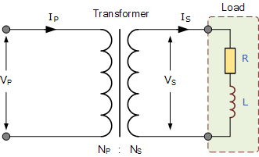
We know that the turns ratio of a transformer states that the total induced voltage in each winding is proportional to the number of turns in that winding and also that the power output and power input of a transformer is equal to the volts times amperes, ( V x I ). Therefore:

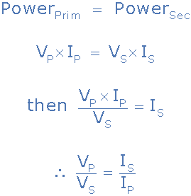
Note that the current is inversely proportional to both the voltage and the number of turns. This means that with a transformer loading on the secondary winding, in order to maintain a balanced power level across the transformers windings, if the voltage is stepped up, the current must be stepped down and vice versa. In other words, “higher voltage — lower current” or “lower voltage — higher current”.
As a transformers ratio is the relationships between the number of turns in the primary and secondary, the voltage across each winding, and the current through the windings, we can rearrange the above transformer ratio equation to find the value of any unknown voltage, ( V ) current, ( I ) or number of turns, ( N ) as shown.
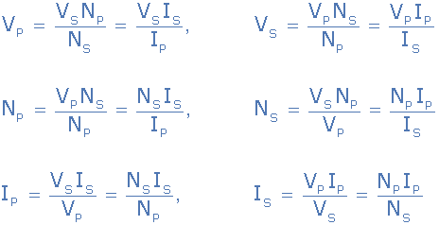
The total current drawn from the supply by the primary winding is the vector sum of the no-load current, Io and the additional supply current, I₁ as a result of the secondary transformer loading and which lags behind the supply voltage by an angle of Φ. We can show this relationship as a phasor diagram.

Transformer Loading Current

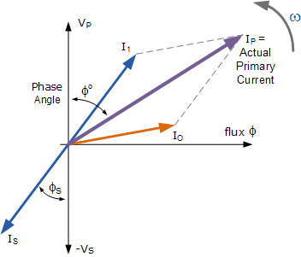
If we are given currents, I_{S} and Io, we can calculate the primary current, I_{P} by the following methods.

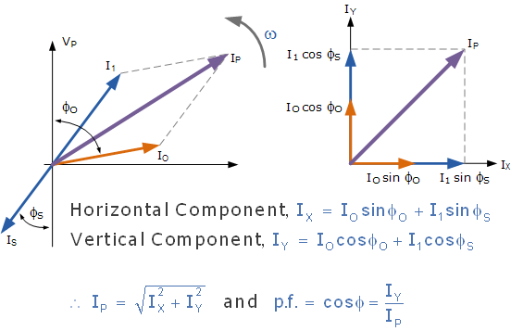

3.9 Equivalent Circuit Diagram

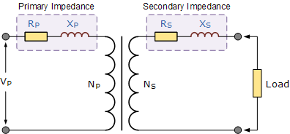

So the primary and secondary windings of a transformer possess both resistance and reactance. Sometimes, it can be more convenient if all these impedances are on the same side of the transformer to make the calculations easier. It is possible to move the primary impedances to the secondary side or the secondary impedances to the primary side. The combined values of R and L impedances are called “Referred Impedances” or “Referred Values”. The object here is to group together the impedances within the transformer and have just one value of R and X_{L} in our calculations as shown.

Combining Transformer Impedances

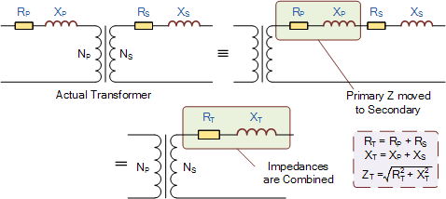

3.10 Transformer Voltage Regulation
The voltage regulation of a transformer is defined as the change in secondary terminal voltage when the transformer loading is at its maximum, i.e. full-load applied while the primary supply voltage is held constant. Regulation determines the voltage drop (or increase) that occurs inside the transformer as the load voltage becomes too low as a result of the transformers loading being to high which therefore affects its performance and efficiency.
Voltage regulation is expressed as a percentage (or per unit) of the no-load voltage. Then if E represents the no-load secondary voltage and V represents the full-load secondary voltage, the percentage regulation of a transformer is given as:

So for example, a transformer delivers 100 volts at no-load and the voltage drops to 95 volts at full load, the regulation would be 5%. The value of E – V will depend upon the internal impedance of the winding which includes its resistance, R and more significantly its AC reactance X, the current and the phase angle.
Also voltage regulation generally increases as the power factor of the load becomes more lagging (inductive). Voltage regulation with regards to the transformer loading can be either positive or negative in value, that is with the no-load voltage as reference, the change down in regulation as the load is applied, or with the full-load as reference and the change up in regulation as the load is reduced or removed.
In general, the regulation of the core type transformer when the transformer loading is high is not as good as the shell type transformer. This is because the shell type transformer has better flux distribution due to the interlacing of the coil windings.
In the next tutorial about Transformers we will look at the Multiple Winding Transformer which has more than one primary winding or more than one secondary winding and see how we can connect two or more secondary windings together in order to supply more voltage or more current to the connected load.
But the beauty of transformers is that they allow us to have more than just one winding in either the primary or secondary side. Transformers which have more than one winding are known commonly as Multiple Winding Transformers.
The principal of operation of a multiple winding transformer is no different from that of an ordinary transformer. Primary and secondary voltages, currents and turns ratios are all calculated the same, the difference this time is that we need to pay special attention to the voltage polarities of each coil winding, the dot convention marking the positive (or negative) polarity of the winding, when we connect them together.
Multiple winding transformers, also known as a multi-coil, or multi-winding transformer, contain more than one primary or more than one secondary coil, hence their name, on a common laminated core. They can be either a single-phase transformer or a three-phase transformer, (multi-winding, multi-phase transformer) the operation is the same.
Multiple Winding Transformers can also be used to provide either a step-up, a step-down, or a combination of both between the various windings. In fact a multiple winding transformers can have several secondary windings on the same core with each one providing a different voltage or current level output.
As transformers operate on the principal of mutual induction, each individual winding of a multiple winding transformer supports the same number of volts per turn, therefore the volt-ampere product in each winding is the same, that is N_{P}/N_{S} = V_{P}/V_{S} with any turns ratio between the individual coil windings being relative to the primary supply.
In electronic circuits, one transformer is often used to supply a variety of lower voltage levels for different components in the electronic circuitry. A typical application of multiple winding transformers is in power supplies and triac switching converters. So a transformer may have a number of different secondary windings, each of which is electrically isolated from the others, just as it is electrically isolated from the primary. Then each of the secondary coils will produce a voltage that is proportional to its number of coil turns for example.

Multiple Winding Transformer

Above shows an example of a typical “multiple winding transformer” which has a number of different secondary windings supplying various voltage levels. The primary windings can be used individually or connected together to operate the transformer from a higher supply voltages.
The secondary windings can be connected together in various configurations producing a higher voltage or current supply. It must be noted that connecting together in parallel transformer windings is only possible if the two windings are electrically identical. That is their current and voltage ratings are the same.

3.11 Transformer Losses
The ability of iron or steel to carry magnetic flux is much greater than it is in air, and this ability to allow magnetic flux to flow is called permeability. Most transformer cores are constructed from low carbon steels which can have permeabilities in the order of 1500 compared with just 1.0 for air.
This means that a steel laminated core can carry a magnetic flux 1500 times better than that of air. However, when a magnetic flux flows in a transformers steel core, two types of losses occur in the steel. One termed “eddy current losses” and the other termed “hysteresis losses”.

Hysteresis Losses
Transformer Hysteresis Losses are caused because of the friction of the molecules against the flow of the magnetic lines of force required to magnetise the core, which are constantly changing in value and direction first in one direction and then the other due to the influence of the sinusoidal supply voltage.
This molecular friction causes heat to be developed which represents an energy loss to the transformer. Excessive heat loss can overtime shorten the life of the insulating materials used in the manufacture of the windings and structures. Therefore, cooling of a transformer is important.
Also, transformers are designed to operate at a particular supply frequency. Lowering the frequency of the supply will result in increased hysteresis and higher temperature in the iron core. So reducing the supply frequency from 60 Hertz to 50 Hertz will raise the amount of hysteresis present, decreased the VA capacity of the transformer.

Eddy Current Losses
Transformer Eddy Current Losses on the other hand are caused by the flow of circulating currents induced into the steel caused by the flow of the magnetic flux around the core. These circulating currents are generated because to the magnetic flux the core is acting like a single loop of wire. Since the iron core is a good conductor, the eddy currents induced by a solid iron core will be large.
Eddy currents do not contribute anything towards the usefulness of the transformer but instead they oppose the flow of the induced current by acting like a negative force generating resistive heating and power loss within the core.

Laminating the Iron Core
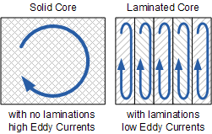
Eddy current losses within a transformer core can not be eliminated completely, but they can be greatly reduced and controlled by reducing the thickness of the steel core. Instead of having one big solid iron core as the magnetic core material of the transformer or coil, the magnetic path is split up into many thin pressed steel shapes called “laminations”.
The laminations used in a transformer construction are very thin strips of insulated metal joined together to produce a solid but laminated core as we saw above. These laminations are insulated from each other by a coat of varnish or paper to increase the effective resistivity of the core thereby increasing the overall resistance to limit the flow of the eddy currents.
The result of all this insulation is that the unwanted induced eddy current power-loss in the core is greatly reduced, and it is for this reason why the magnetic iron circuit of every transformer and other electro-magnetic machines are all laminated. Using laminations in a transformer construction reduces eddy current losses.
The losses of energy, which appears as heat due both to hysteresis and to eddy currents in the magnetic path, is known commonly as “transformer core losses”. Since these losses occur in all magnetic materials as a result of alternating magnetic fields. Transformer core losses are always present in a transformer whenever the primary is energized, even if no load is connected to the secondary winding. Also these hysteresis and the eddy current losses are sometimes referred to as “transformer iron losses”, as the magnetic flux causing these losses is constant at all loads.

Copper Losses
But there is also another type of energy loss associated with transformers called “copper losses”. Transformer Copper Losses are mainly due to the electrical resistance of the primary and secondary windings. Most transformer coils are made from copper wire which has resistance in Ohms, ( Ω ). This resistance opposes the magnetising currents flowing through them.
When a load is connected to the transformers secondary winding, large electrical currents flow in both the primary and the secondary windings, electrical energy and power ( or the I² R ) losses occur as heat. Generally copper losses vary with the load current, being almost zero at no-load, and at a maximum at full-load when current flow is at maximum.
A transformers VA rating can be increased by better design and transformer construction to reduce these core and copper losses. Transformers with high voltage and current ratings require conductors of large cross-section to help minimise their copper losses. Increasing the rate of heat dissipation (better cooling) by forced air or oil, or by improving the transformers insulation so that it will withstand higher temperatures can also increase a transformers VA rating.
Then we can define an ideal transformer as having:
- No Hysteresis loops or Hysteresis losses → 0
- Infinite Resistivity of core material giving zero Eddy current losses → 0
- Zero winding resistance giving zero I²*R copper losses → 0
In the next tutorial about Transformers we will look at Transformer Loading of the secondary winding with respect to an electrical load and see the effect a “NO-load” and a “ON-load” connected transformer has on the primary winding cu
In the previous transformer tutorials, we have assumed that the transformer is ideal, that is one in which there are no core losses or copper losses in the transformers windings. However, in real world transformers there will always be losses associated with the transformers loading as the transformer is put “on-load”. But what do we mean by: Transformer Loading.
Well first let’s look at what happens to a transformer when it is in this “no-load” condition, that is with no electrical load connected to its secondary winding and therefore no secondary current flowing.

3.12. O.C. and S.C. Tests on Single Phase Transformer
The efficiency and regulation of a transformer on any load condition and at any power factor condition can be predetermined by indirect loading method. In this method, the actual load is not used on transformer. But the equivalent circuit parameters of a transformer are determined by conducting two tests on a transformer which are,
1. Open circuit test (O.C Test)
2. Short circuit test (S.C.Test)
The parameters calculated from these test results are effective in determining the regulation and efficiency of a transformer at any load and power factor condition, without actually loading the transformer. The advantage of this method is that without much power loss the tests can be performed and results can be obtained. Let us discuss in detail how to perform these tests and how to use the results to calculate equivalent circuit parameters.
1.1 Open Circuit Test (O.C. Test)
The experimental circuit to conduct O.C test is shown in the Fig. 1.

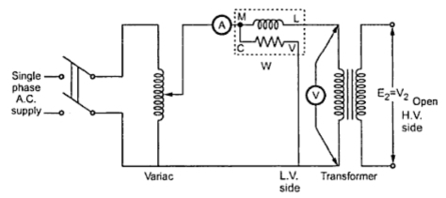
The transformer primary is connected to a.c. supply through ammeter, wattmeter and variac. The secondary of transformer is kept open. Usually low voltage side is used as primary and high voltage side as secondary to conduct O.C test.
The primary is excited by rated voltage, which is adjusted precisely with the help of a variac. The wattmeter measures input power. The ammeter measures input current. The voltemeter gives the value of rated primary voltage applied at rated frequency.
Sometimes a voltmeter may be connected across secondary to measure secondary voltage which is V₂ = E₂ when primary is supplied with rated voltage. As voltmeter resistance is very high, though voltmeter is connected, secondary is treated to be open circuit as voltmeter current is always negligibly small.
When the primary voltage is adjusted to its rated value with the help of variac, readings of ammeter and wattmeter are to be recorded.
The observation table is as follows
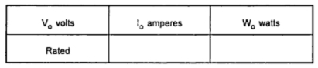
V_{o} = Rated voltage
W_{o} = Input power
I_{o} = Input current = no load current
As transformer secondary is open, it is on no load. So current drawn by the primary is no load current I_{o}. The two components of this no load current are,
I_{m} = I_{o} sin Φ_{o}
I_{c} = I_{o} cos Φ_{o}
where cos Φ_{o} = No load power factor
And hence power input can be written as,
W_{o} = V_{o} I_{o} cos Φ_{o}
The phasor diagram is shown in the Fig. 2.
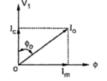
As secondary is open, I₂ = 0. Thus its reflected current on primary is also zero. So we have primary current I₁ =I_{o}. The transformer no load current is always very small, hardly 2 to 4 % of its full load value. As I₂ = 0, secondary copper losses are zero. And I₁ = I_{o} is very low hence copper losses on primary are also very very low. Thus the total copper losses in O.C. test are negligibly small. As against this the input voltage is rated at rated frequency hence flux density in the core is at its maximum value. Hence iron losses are at rated voltage. As output power is zero and copper losses are very low, the total input power is used to supply iron losses. This power is measured by the wattmeter i.e. W_{o}. Hence the wattmeter in O.C. test gives iron losses which remain constant for all the loads.
... W_{o} = P_{i} = Iron losses
Calculations : We know that,
W_{o} = V_{o} I_{o} cos Φ
cos Φ_{o} = W_{o} /(V_{o} I_{o} ) = no load power factor
Once cos Φ_{o} is known we can obtain,
I_{c} = I_{o} cos Φ_{o}
and I_{m} = I_{o} sin Φ_{o}
Once I_{c} and I_{m} are known we can determine exciting circuit parameters as,
R_{o} = V_{o} /I_{c} Ω
and X_{o} = V_{o} /I_{m} Ω
Key Point : The no load power factor cos Φ_{o} is very low hence wattmeter used must be low power factor type otherwise there might be error in the results. If the meters are connected on secondary and primary is kept open then from O.C. test we get R_{o}' and X_{o}' with which we can obtain R_{o} and X_{o}knowing the transformation ratio K.
1.2 Short Circuit Test (S.C. Test)
In this test, primary is connected to a.c. supply through variac, ammeter and voltmeter as shown in the Fig. 3.

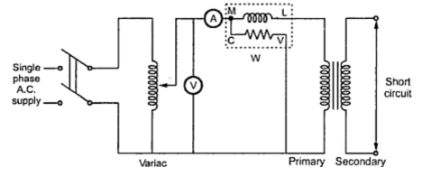
The secondary is short circuited with the help of thick copper wire or solid link. As high voltage side is always low current side, it is convenient to connect high voltage side to supply and shorting the low voltage side.
As secondary is shorted, its resistance is very very small and on rated voltage it may draw very large current. Such large current can cause overheating and burning of the transformer. To limit this short circuit current, primary is supplied with low voltage which is just enough to cause rated current to flow through primary which can be observed on an ammeter. The low voltage can be adjusted with the help of variac. Hence this test is also called low voltage test or reduced voltage test. The wattmeter reading as well as voltmeter, ammeter readings are recorded. The observation table is as follows,

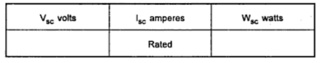

Now the current flowing through the windings are rated current hence the total copper loss is full load copper loss. Now the voltage supplied is low which is a small fraction of the rated voltage. The iron losses are function of applied voltage. So the iron losses in reduced voltage test are very small. Hence the wattmeter reading is the power loss which is equal to full load copper losses as iron losses are very low.
... W_{sc} = (P_{cu}) F.L. = Full load copper loss
Calculations : From S.C. test readings we can write,
W_{sc} = V_{sc} I_{sc} cos Φ_{sc}
... cos Φsc = V_{sc} I_{sc} /W_{sc} = short circuit power factor
W_{sc} = I_{sc}² R_{1e} = copper loss
... R_{1e} =W_{sc} /I_{sc}²
while Z_{1e} =V_{sc} /I_{sc} = √(R_{1e}² + X_{1e}²)
... X_{1e} = √(Z_{1e}² - R_{1e}²)
Thus we get the equivalent circuit parameters R_{1e}, X_{1e} and Z_{1e}. Knowing the transformation ratio K, the equivalent circuit parameters referred to secondary also can be obtained.

3.12 Efficiency
A transformer does not require any moving parts to transfer energy. This means that there are no friction or windage losses associated with other electrical machines. However, transformers do suffer from other types of losses called “copper losses” and “iron losses” but generally these are quite small.
Copper losses, also known as I²R loss is the electrical power which is lost in heat as a result of circulating the currents around the transformers copper windings, hence the name. Copper losses represents the greatest loss in the operation of a transformer. The actual watts of power lost can be determined (in each winding) by squaring the amperes and multiplying by the resistance in ohms of the winding (I²R).
Iron losses, also known as hysteresis is the lagging of the magnetic molecules within the core, in response to the alternating magnetic flux. This lagging (or out-of-phase) condition is due to the fact that it requires power to reverse magnetic molecules; they do not reverse until the flux has attained sufficient force to reverse them.
Their reversal results in friction, and friction produces heat in the core which is a form of power loss. Hysteresis within the transformer can be reduced by making the core from special steel alloys.
The intensity of power loss in a transformer determines its efficiency. The efficiency of a transformer is reflected in power (wattage) loss between the primary (input) and secondary (output) windings. Then the resulting efficiency of a transformer is equal to the ratio of the power output of the secondary winding, P_{S} to the power input of the primary winding, P_{P} and is therefore high.
An ideal transformer is 100% efficient because it delivers all the energy it receives. Real transformers on the other hand are not 100% efficient and at full load, the efficiency of a transformer is between 94% to 96% which is quiet good. For a transformer operating with a constant voltage and frequency with a very high capacity, the efficiency may be as high as 98%.

Transformer Efficiency
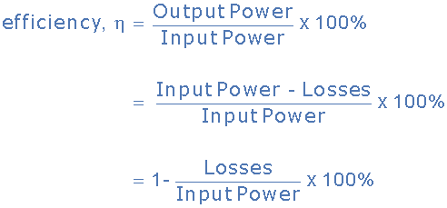
Where: Input, Output and Losses are all expressed in units of power.
Generally when dealing with transformers, the primary watts are called “volt-amps”, VA to differentiate them from the secondary watts. Then the efficiency equation above can be modified to:
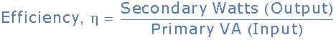

It is sometimes easier to remember the relationship between the transformers input, output and efficiency by using pictures. Here the three quantities of VA, W and η have been superimposed into a triangle giving power in watts at the top with volt-amps and efficiency at the bottom. This arrangement represents the actual position of each quantity in the efficiency formulas.

In both types of transformer core design, the magnetic flux linking the primary and secondary windings travels entirely within the core with no loss of magnetic flux through air.

3.13 Autotransformer

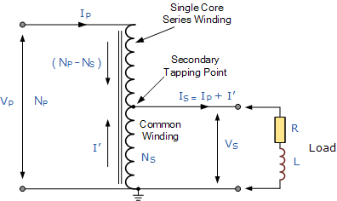

When the primary current I_{P} is flowing through the single winding in the direction of the arrow as shown, the secondary current, I_{S}, flows in the opposite direction. Therefore, in the portion of the winding that generates the secondary voltage, V_{S} the current flowing out of the winding is the difference of I_{P} and I_{S}.
The Autotransformer can also be constructed with more than one single tapping point. Auto-transformers can be used to provide different voltage points along its winding or increase its supply voltage with respect to its supply voltage V_{P} as shown.

Autotransformer with Multiple Tapping Points
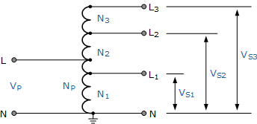

The standard method for marking an auto-transformer windings is to label it with capital (upper case) letters. So for example, A, B, Z etc to identify the supply end. Generally the common neutral connection is marked as N or n. For the secondary tapping’s, suffix numbers are used for all tapping points along the auto-transformers primary winding. These numbers generally start at number “1” and continue in ascending order for all tapping points as shown.

Autotransformer Terminal Markings
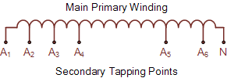

An autotransformer is used mainly for the adjustments of line voltages to either change its value or to keep it constant. If the voltage adjustment is by a small amount, either up or down, then the transformer ratio is small as V_{P} and V_{S} are nearly equal. Currents I_{P} and I_{S}are also nearly equal.
Therefore, the portion of the winding which carries the difference between the two currents can be made from a much smaller conductor size, since the currents are much smaller saving on the cost of an equivalent double wound transformer.
However, the regulation, leakage inductance and physical size (since there is no second winding) of an autotransformer for a given VA or KVA rating are less than for a double wound transformer.
Autotransformer’s are clearly much cheaper than conventional double wound transformers of the same VA rating. When deciding upon using an autotransformer it is usual to compare its cost with that of an equivalent double wound type.
This is done by comparing the amount of copper saved in the winding. If the ratio “n” is defined as the ratio of the lower voltage to the higher voltage, then it can be shown that the saving in copper is: n*100%. For example, the saving in copper for the two autotransformers would be:
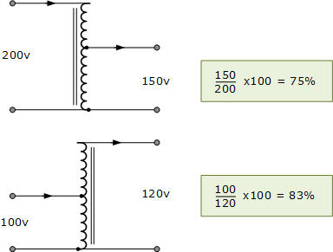

Autotransformer Example No1
An autotransformer is required to step-up a voltage from 220 volts to 250 volts. The total number of coil turns on the transformer main winding is 2000. Determine the position of the primary tapping point, the primary and secondary currents when the output is rated at 10KVA and the economy of copper saved.
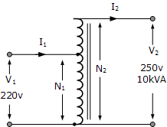 | 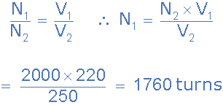
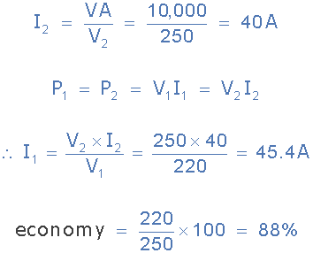

Thus the primary current is 45.4 amperes, the secondary current drawn by the load is 40 amperes and 5.4 amperes flows through the common winding. The economy of copper is 88%.

Disadvantages of an Autotransformer
- The main disadvantage of an autotransformer is that it does not have the primary to secondary winding isolation of a conventional double wound transformer. Then an autotransformer can not safely be used for stepping down higher voltages to much lower voltages suitable for smaller loads.
- If the secondary side winding becomes open-circuited, load current stops flowing through the primary winding stopping the transformer action resulting in the full primary voltage being applied to the secondary terminals.
- If the secondary circuit suffers a short-circuit condition, the resulting primary current would be much larger than an equivalent double wound transformer due to the increased flux linkage damaging the autotransformer.
- Since the neutral connection is common to both the primary and secondary windings, earthing of the secondary winding automatically Earth’s the primary as there is no isolation between the two windings. Double wound transformers are sometimes used to isolate equipment from earth.
The autotransformer has many uses and applications including the starting of induction motors, used to regulate the voltage of transmission lines, and can be used to transform voltages when the primary to secondary ratio is close to unity.
An autotransformer can also be made from conventional two-winding transformers by connecting the primary and secondary windings together in series and depending upon how the connection is made, the secondary voltage may add to, or subtract from, the primary voltage.

The Variable Autotransformer
As well as having a fixed or tapped secondary that produces a voltage output at a specific level, there is another useful application of the auto transformer type of arrangement which can be used to produce a variable AC voltage from a fixed voltage AC supply. This type of Variable Autotransformer is generally used in laboratories and science labs in schools and colleges and is known more commonly as the Variac.
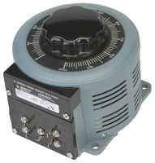
The construction of a variable autotransformer, or variac, is the same as for the fixed type. A single primary winding wrapped around a laminated magnetic core is used as in the auto transformer but instead of being fixed at some predetermined tapping point, the secondary voltage is tapped through a carbon brush.
This carbon brush is rotated or allowed to slide along an exposed section of the primary winding, making contact with it as it moves supplying the required voltage level.
Then a variable autotransformer contains a variable tap in the form of a carbon brush that slides up and down the primary winding which controls the secondary winding length and hence the secondary output voltage is fully variable from the primary supply voltage value to zero volts.
The variable autotransformer is usually designed with a significant number of primary windings to produce a secondary voltage which can be adjusted from a few volts to fractions of a volt per turn. This is achieved because the carbon brush or slider is always in contact with one or more turns of the primary winding. As the primary coil turns are evenly spaced along its length. Then the output voltage becomes proportional to the angular rotation.

Variable Autotransformer
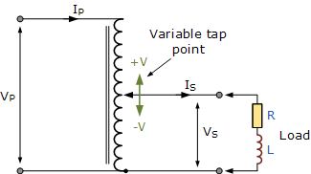

We can see that the variac can adjust the voltage to the load smoothly from zero to the rated supply voltage. If the supply voltage was tapped at some point along the primary winding, then potentially the output secondary voltage could be higher than the actual supply voltage. Variable autotransformer’s can also be used for the dimming of lights and when used in this type of application, they are sometimes called “dimmerstats”.
Variacs are also very useful in electrical and electronics workshops and labs as they can be used to provide a variable AC supply. But caution needs to be taken with suitable fuse protection to ensure that the higher supply voltage is not present at the secondary terminals under fault conditions.
The Autotransformer have many advantages over conventional double wound transformers. They are generally more efficient for the same VA rating, are smaller in size, and as they require less copper in their construction, their cost is less compared to double wound transformers of the same VA rating. Also, their core and copper losses, I²R are lower due to less resistance and leakage reactance giving a superior voltage regulation than the equivalent two winding transformer.

3.14 Types of transformer

- Power transformers
- Distribution transformers
- Instrument transformers
- Autotransformers
- Dry-type/Cast-resin transformers
- Arc furnace transformers
- Rectifier transformers
- Traction transformers
- Earthing transformers
- Subsea transformers
- Isolation transformers
- Booster transformers
- RF and audio transformers
- Phase shifting transformers
- Welding transformers
- Converter transformers

Types of Transformers on the Basis of Applications
The transformers are often classified on the basis of the purposes for which they are used. Following are the important types of transformers on the basis of applications:
Power Transformers
These transformers are used at the power plants to step-up the generated voltage for transmission purposes and to step down the voltage at the receiving substations. These are large size transformers.
These transformers are usually operated near the full load which would cause high copper loss. Thus, to have minimum losses, such transformers are designed with low copper losses and to give maximum efficiency at near the full load.
Distribution Transformers
These transformers are used to step down the voltage at the distribution substations. The load on such transformers varies for all the 24 hours from no load to full load.
Such transformers are designed with low iron loss and to give maximum efficiency at about 75% of the full load to obtain high efficiency.
Instrument Transformers
These transformers are used to measure high voltage, high current and to operate protective devices. To measure high voltage, it is stepped down with an instrument transformer which is known as the potential transformer (PT) and then applied to a voltmeter. Similarly, to measure high current, it is stepped down with an instrument transformer which is known as the current transformer (CT) and then applied to an ammeter.
Testing Transformers
To carry out the tests under high, voltages testing transformers are used to step-up the voltage to a very high value.
Special Transformers
These are used to operate welding sets, rectifiers, electric furnaces etc.

3.15 Ratings and specifications of Single Phase Transformer
Ratings:
Manufacturer designs transformer based on required voltage and current and specified them on the nameplate of the transformer in terms of VA called the rating. It can be also said that the maximum voltage and current that can be safely applied to transformer called the rating. The rating of transformer depends upon temperature rise which depends upon losses taking place in the transformer. Although temperature can be maintained within permissible limits by using the proper cooling system. If the effectiveness of the cooling system is more then the rating of the transformer will be more and vice versa. For a given cooling system rating of an electrical machine is indirectly determined by the losses present in the machine.
In a transformer, losses are of two types
- Constant losses or core losses – These depend on V
- Variable losses or ohmic (I²R) losses – These depend on I
Hence total losses depend on V and I. Since rating of transformer depends upon losses and losses depends upon V and I, hence the rating of transformer depends upon V×I, which is also termed as VI rating. As losses are independent of the power factor of load, the rating of the transformer is also independent of load and can be only decided based on losses. That’s why transformer is generally specified with apparent power rating (VA or KVA) and not in KW.

STANDARD RATINGS: 2.1 The standard ratings shall be 10, 16, 25, 63, 100, 160, 200, 250, 315, 400, 500, 630, 1000, 1250, 1600, 2000 and 2500 kVA for 11 kV distribution transformers and 100, 160, 200, 315, 400, 500, 630, 1000, 1250, 1600, 2000, 2500 kVA for 33 kV distribution transformers.
Specifications:
This specification covers design, engineering, manufacture, assembly, stage testing, inspection and testing before supply and delivery at site of oil immersed, naturally cooled 3 phase 11 kV/433 - 250 V and 33 kV/433-250 V distribution transformers for outdoor use. 1.2 It is not the intent to specify completely herein all the details of the design and construction of equipment. However the equipment shall conform in all respects to high standards of engineering, design and workmanship and shall be capable of performing in continuous commercial operation, in a manner acceptable to the purchaser, who will interpret the meanings of drawings and specification and shall have the power to reject any work or material which, in his judgment is not in accordance therewith. The offered equipment shall be complete with all components necessary for their effective and trouble free operation. Such components shall be deemed to be within the scope of bidder’s supply irrespective of whether those are specifically brought out in this specification and / or the commercial order or not. 1.3 The transformer and accessories shall be designed to facilitate operation, inspection, maintenance and repairs. The design shall incorporate every precaution and provision for the safety of equipment as well as staff engaged in operation and maintenance of equipment. 1.4 All outdoor apparatus, including bushing insulators with their mountings, shall be designed so as to avoid any accumulation of water.

